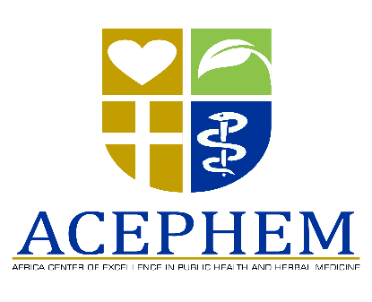

KAMUZU COLLEGE OF NURSING

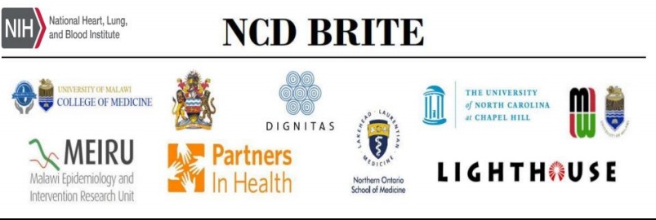

CALL FOR APPLICATIONS:

SCIENTIFIC PROPOSAL WRITING WORKSHOP
The African Centre of excellence in public health and herbal medicine (ACEPHEM) in collaboration with The Non-Communicable Diseases (NCDs) Building Research Capacity, Implementation and Translation Expertise (NCD BRITE) program is pleased to announce a workshop on scientific proposal writing.
Dates: 15th-17th October, 2019.
Venue: Kamuzu College of Nursing, Blantyre Campus, Kameza
Target Audience: Investigators, young researchers, postgraduate fellows and all interested.
About the course: The following modules shall be delivered
- Understand the proposal writing process
- Develop different kinds of proposals
- Targeting proposals for an appropriate audience
- Identifying potential funders for different ideas
- Performing needs analysis that will enable development of a feasible proposal
- Format their proposal professionally
- Construct words, sentences and paragraphs professionally

Workshop fees: ACEPHEM and NCD BRITE will provide tuition scholarship only. Participants and/or their institutions are expected to contribute accommodation and transport to and from the workshop.
Contact and applications: Interested prospective applicants should send an email requesting a registration form to:
amakuta@medcol.mw
cc: rsctrainingcoordination@medcol.mw / emokiwa@medcol.mw.
CLOSING DATE FOR RECEIVING APPLICATIONS: 10TH OCTOBER 2019

